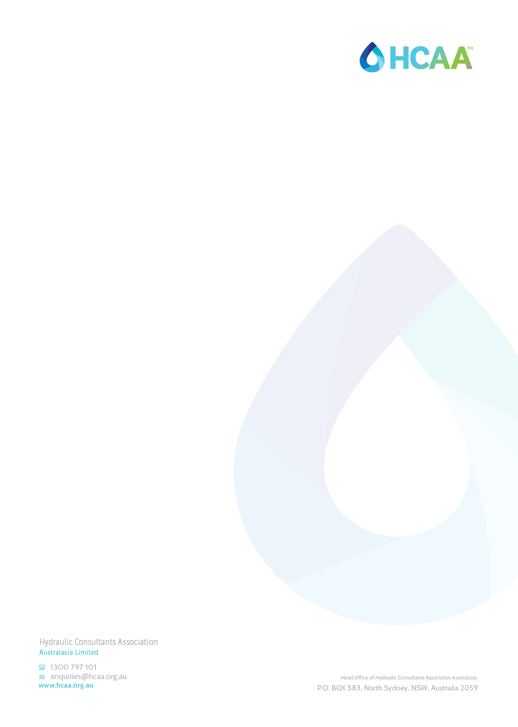
HYDRAULIC SERVICES WITNESS TESTING
HCAA-025 – SURFACE AND SUBSTANCE DRAINAGE SYSTEMS Commissioning Sheet
V2021.01 - April 2021

GENERAL NOTES: This form is to be used for the purpose of witness testing a hydraulic installation by a suitably Qualified Hydraulic Consultant. Completion of all applicable sections is required. This form should be filed to the relevant project folder within 10 business days after witnessing has occurred.
Notes: This series of Hydraulic Testing Procedures have been designed to assist the Hydraulic Services Consultant to carry out suitable witness testing at the end of a project. Each set of procedures details an industry accepted, list of objectives, that the Hydraulic Services Consultant should carry out to fulfil their design commission. The series of procedures will offer the client security in the knowledge that the objectives identified have been based on an Industry standard, endorsed by the HCAA (National), which represents the Professional Industry of Hydraulic Services Consultants.

Project: |  | Project Number:
Prepared By: |  | Report Date:
Plumbing Company: |  | Consulting Company:
Plumbers Name: |  | Consultant’s name:
Plumbers license number |  | Consultant’s certification number:
Date of Test/Inspection: |  | Drawing Revision:
Equipment
Flow Test Kit
The hydraulic services elements of the Project have been tested in accordance with:
Number | Title
NCC Volume 1 | Building Code of Australia 2019
PCA 2019 | Plumbing Code of Australia 2019
AS/NZS 3500.1-2018 | Plumbing and Drainage -Part 3: Stormwater services

Plumbers Declaration | I hereby state that that the information provided in this form is a true and accurate record.
 | Signature: | Date:
Consultants Declaration | I hereby state that that the information provided in this form is a true and accurate record.
 | Signature: | Date:

The hydraulic services being tested and recorded in this document are:

 | Yes | No
Test roof drainage system and validate against design
Validate any freeboard against the design

