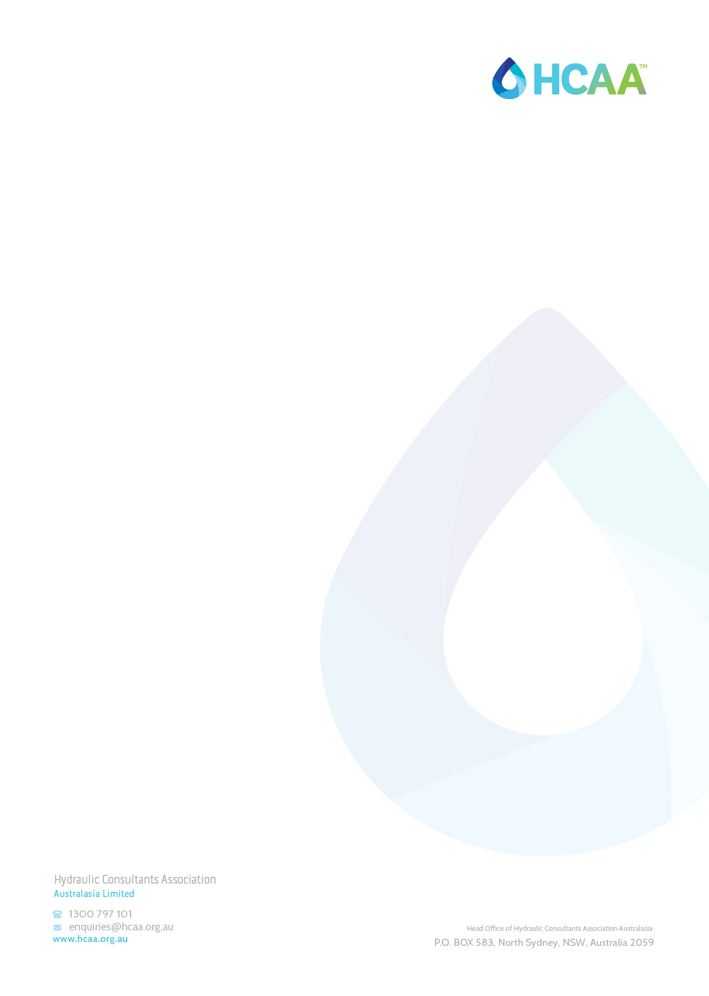
HYDRAULIC SERVICES WITNESS TESTING
HCAA-027 – SPECIALTY WATER SYSTEMS, SANITARY PLUMBING SYSTEMS, SANITARY DRAINAGE SYSTEMS AND ON-SITE TREATMENT SYSTEMS FOR HEALTHCARE FACILITIES COMMISSIONING SHEET
V2021.01 - April 2021

GENERAL NOTES: This form is to be used for the purpose of witness testing a hydraulic installation by a suitably Qualified Hydraulic Consultant. Completion of all applicable sections is required. This form should be filed to the relevant project folder within 10 business days after witnessing has occurred.
Notes: This series of Hydraulic Testing Procedures have been designed to assist the Hydraulic Services Consultant to carry out suitable witness testing at the end of a project. Each set of procedures details an industry accepted, list of objectives, that the Hydraulic Services Consultant should carry out to fulfil their design commission. The series of procedures will offer the client security in the knowledge that the objectives identified have been based on an Industry standard, endorsed by the HCAA (National), which represents the Professional Industry of Hydraulic Services Consultants.

Project: |  | Project Number:
Prepared By: |  | Report Date:
Plumbing Company: |  | Consulting Company:
Plumbers Name: |  | Consultant’s name:
Plumbers license number |  | Consultant’s certification number:
Date of Test/Inspection: |  | Drawing Revision:
Equipment
The hydraulic services elements of the Project have been tested in accordance with:
Number | Title
NCC Volume 1 | Building Code of Australia 2019
PCA 2019 | Plumbing Code of Australia 2019
AS/NZS 3500.1-2018 | Plumbing and Drainage -Part 1: Water services

Plumbers Declaration | I hereby state that that the information provided in this form is a true and accurate record.
 | Signature: | Date:
Consultants Declaration | I hereby state that that the information provided in this form is a true and accurate record.
 | Signature: | Date:

- CSSD RO

Work Description:

 | Yes | No
Validate correct velocity and pipework reticulation
Validate main and min pressure against design under static
Validate controls of the system
Validate overheat safety feature

