The HCAA has issued these documents for use by competent personnel deemed by the local and state/territory-based engineering community & regulations. These templates are generic and pursuit to the requirements of the National Construction Code (NCC) require input by a suitably qualified personal. The templates are by no way are a complete guidance document and are expected to be used by suitably qualified personal capable of understanding performance solutions as defined by the NCC. Some example guidance has been added for the State of NSW, this is to be suitably adjusted as required and verified. All data within this document is to be suitably verified by the suitably qualified person prior to use. The HCAA provides no warranty, no guarantee, or the like to the accuracy, validity or appropriateness of this data to your situation. Please be advised that you are using these documents at your own risk.
- Find and replace (Ctrl + H) the following words to assist in completing the report:
- InsertProjectName
- InsertProjectAddress
- InsertRevisionNumber
- InsertRevisionName
- InsertDate
- InsertDesignerName
- InsertCompanyName
- InsertCompanyAddress
- InsertCompanyPhoneNumber
- InsertCompanyEmail
- InsertClientName
- InsertClientAddress
- InsertClientPhoneNumber
- InsertClientEmail
- InsertDesignerTitle
- InsertDesignerQualifications
- InsertReviewerName
- InsertReviewerCompanyName
- InsertReviewerTitle
- InsertReviewerQualifications
- InsertNetworkUtilityOperatorName
- Insert all required Figures and Tables and reference them.
- Add any sections you feel need to be added.
- Yellow sections need you to insert information.
- Send to the Private Certifier for their review and approval
- Note in your design certificate that you have used a performance solution

This page is a guide to the use of the performance solution template and does not form part of the performance solution, ensure this page is deleted prior to submitting the performance solution.

InsertCompanyLogo

InsertProjectName
InsertProjectAddress
Performance Solution – Pipe Articulation Design for Unstable and Reactive Soils

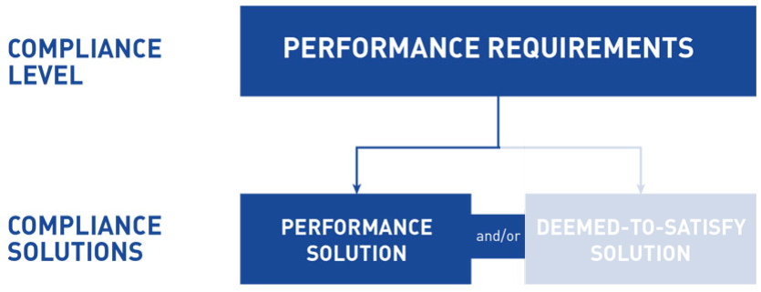

Revision # | Revision Name | Date | Author
InsertRevisionNumber | InsertRevisionName | InsertDate | InsertDesignerName

Prepared By:
InsertCompanyName
InsertCompanyAddress
InsertCompanyPhoneNumber
InsertCompanyEmail
Prepared For:
InsertClientName
InsertClientAddress
InsertClientPhoneNumber
InsertClientEmail

Executive Summary

These performance requirements relate specifically to the design and installation of flexible connections and clay plugs when working in unstable and reactive soils. Whilst these systems are regularly installed around Australia, they do not currently comply with the DTS requirements of the BCA Volume 1 2019, the PCA 2019 or AS/NZS3500.2 2018. This Performance solution has been produced to satisfy the performance requirements of the Plumbing Code of Australia in relation to an articulated design.

This performance solution meets the requirements of the Plumbing Code of Australia 2019 clause A2.1 “Compliance with the Performance Requirements” and has been verified in accordance clause A2.2 “Performance Solution” It has been prepared in combination with the DTS requirements of section 5.6 of AS2870 and Appendix G of AS/NZS 3500.2.2020 (proposed to be included in NCC 2022).

The installation of flexible connections and clay plugs to help risk proof drains from destructive ground movement forms part of AS2870:2011 Residential Slabs and Footings and is consequently referenced in AS/NZS 3500.2. Flexible connection products are watermarked under WMTS-055:2016 and WMTS519:2016 and AS/NZS1260:2017

This Performance Solution Pertains To:

The design and installation of PVC-U and HDPE in any sanitary drainage, liquid trade waste drainage or stormwater drainage system, when working with Class M, H1, H2 and E soil classifications as defined in AS2870:2011

This Performance Solutions Has Been Prepared By:

Designer: Insert Designer Name
Company: Insert Company Name
Title: Insert Designer Title
Qualifications: Insert Designer Qualifications
Contents

1. Introduction 4
2. Reason for the Performance Solution 4
3. Benefits of Using a Performance Solution 4
4. Site Specific Information 5
5. Design Information 5
6. Overview of the Soil Classifications 6
7. Overview of Compliance 7
8. Verification Against the Performance Requirements 7
9. Adopted DTS Solutions 9
10. Conclusion 13
Appendix A – Geotechincal Report 14
Appendix B – CV of Designer 15
Appendix C – Expert Assessment 16
Appendix D – Client Acknowledgement Letter 17

Update the contents and delete this text once the template has been completed

Introduction

Insert Company Name are engaged by Insert Client Name to design the drainage system on Insert Project Name which is located at Insert Project Address. Refer to the below site plan for an overview of the project location.

Insert Site Plan

The Plumbing Code of Australia 2019, section CP1.1 (2)(c) states- “a sanitary plumbing system must avoid the following: damage from superimposed loads, ground movement or root penetration.” It also states, “there are no verification methods in this part” and as such we are using methods outlined in other standards as the basis for this design.
AS/NZS 3500.2: 2018 Sanitary Plumbing and Drainage (as referenced in PCA 2019) Does not contain any reference to drainage designs in unstable soils.
AS/NZS 3500.2: 2020(DRAFT) Sanitary Plumbing and Drainage (proposed to be referenced in PCA 2022) contains Appendix G – Drains in Unstable Soils. This informative section covers the requirements of installing drainage in M, H1, H2 and E classification soil sites. As it is informative and additionally not referenced in the PCA 2019 we are using these design principals via this performance solution.
AS2870:2011 Residential Slabs and Footings (as referenced in BCA 2019) contains deemed-to-satisfy (DTS) solutions on the installation of Flexible Connections and Clay Plugs. As it is not referenced in the PCA 2019 we are using these design principals via this performance solution.
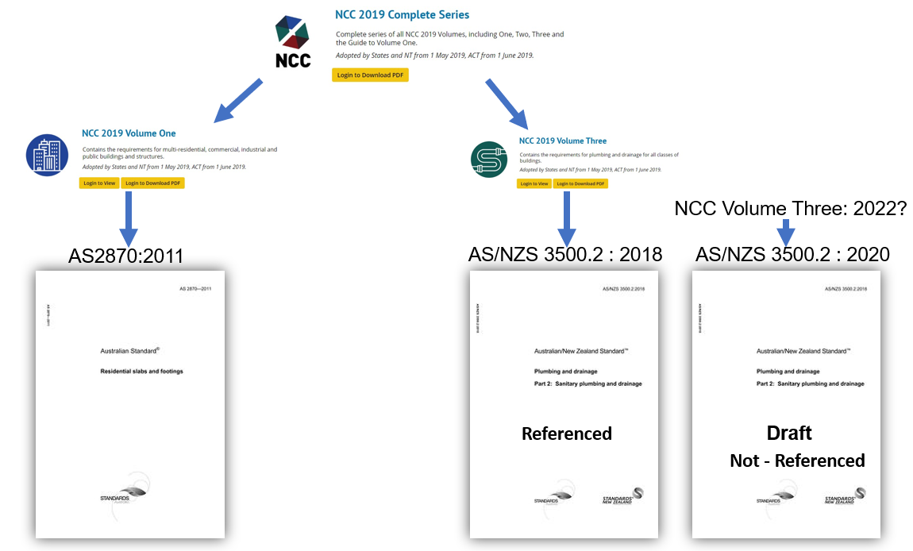

Reason for the Performance Solution

Moisture content, or lack thereof, can greatly impact the volume certain soils (this swelling and contracting of the soil gives them the name ‘reactive’). Installing PVC and HDPE drainage in unstable and reactive soils without the proper articulation can result in the cracking and shearing of pipe and fittings. The subsequent excess moisture and consequential heave can cause further damage the remaining drainage system and can have a catastrophic effect on the slab and supported structure.
The Hydraulics Industry as a whole, recognises the need to provide the necessary articulation to accommodate the characteristic movement of the site and to protect the drainage system.

Benefits of Using a Performance Solution

The benefit of using a performance solution for articulation of the drainage system is to risk proof pipes and fittings against destructive ground movement and to protect the slab and supported structure. As a result of this, the clients receive a design that:
- Reduces the risk of broken pipes and fittings
- Prevents water from entering under the slab from groundwater
- Prevents the escape of wastewater into the surrounding soils

Site Specific Information

A copy of the geotechnical report has been obtained and is attached in the appendix of this performance solution. The classification of the soil contained in this report is -
- Site Classification: INSERT TEXT HERE
- Expected Soil Movement: INSERT TEXT HERE (mm)
Designer Notes: If the geotechnical report states that the site is a P classification further clarification of the characteristic value (shrink / swell) must be obtained.
If the geotechnical report states that the site is a P classification; the reasons for this determination are -
- Add reasons for why the site was classified as “XXX”.
Based on this, what site design issues have been considered?
- The base of trenches shall be sloped away from the building
- Surface drainage shall be controlled from the start of site preparation and construction
- Sub-surface drainage of the site shall be a minimum 1.5 metres away from the building
- Add any further site-specific recommendations

Design Information – for drainage that exits below the slab
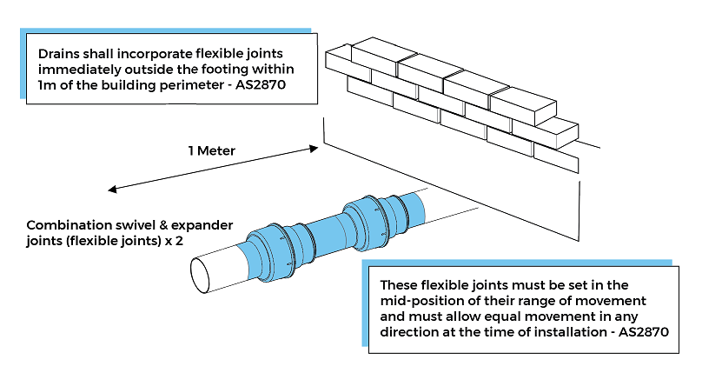
Articulation detail – Eternal to slab, for soil classifications H1, H2 and E
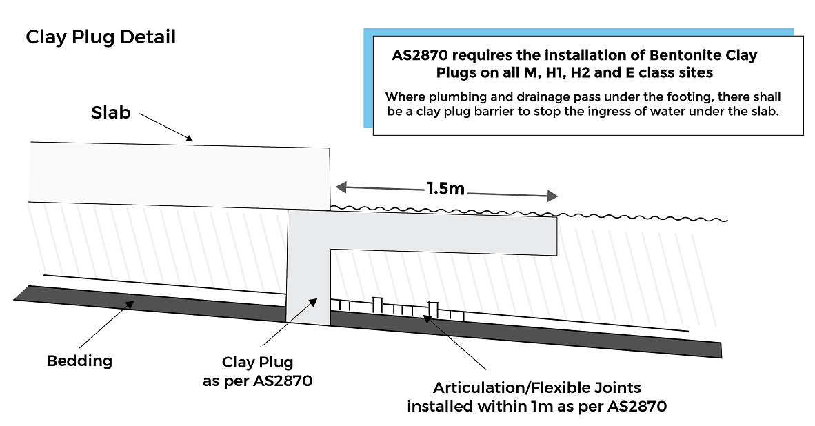
Clay Plug Provided for soil classifications M, H1, H2 and E

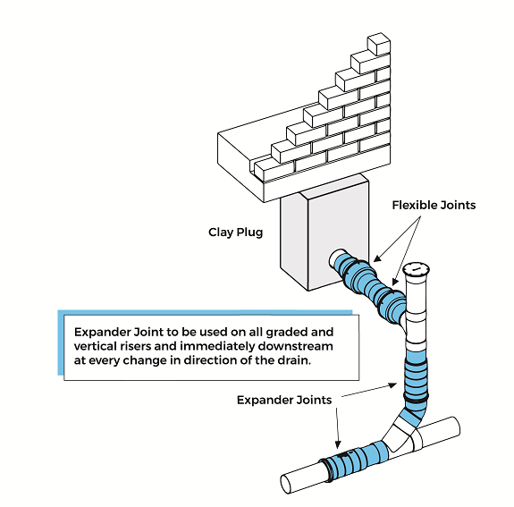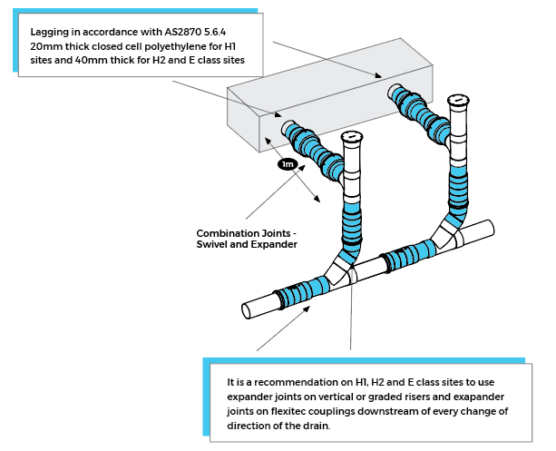
Articulation Provided at changes of direction and immediately downstream at every change of direction – Pipes to be lagged where passing through concrete for soil classifications H1, H2 and E
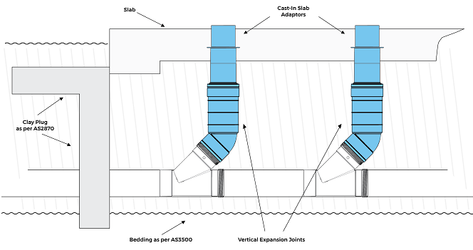
Articulation to be provided under the slab for soil classifications H1, H2 and E
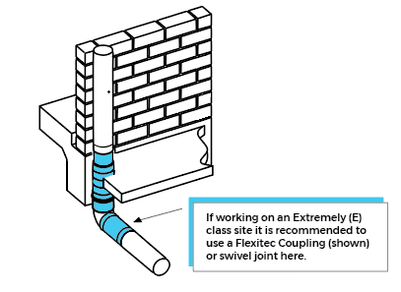
Storm Water Detail – Downpipe through slab for soil classifications H1, H2 and E

6. Overview of the Soil Classifications

Soil classification table as per AS2870:2011 shown below.
All services in area’s H1/H2/E/P are to have provision for ground movement
This Site | Soil Classifications | Soil Description | Expected range of movement
 | A | Most sand and rock sites with little or no ground movement from moisture changes
 | S | Slightly reactive clay sites, which may experience only slight ground movement from moisture changes. | 0-20mm
 | M | Moderately reactive clay or silt sites, which may experience moderate  Ground movement from moisture changes. | 20-40mm
 | H1 | Highly reactive Clay sites, which may experience high ground movement  from moisture changes | 40-60mm
This Site Is H2 | H2 | Highly reactive Clay sites, which may experience very high ground movement from moisture change  NOTE: To be used for all projects located within mine subsidence area’s | 60-75mm
 | E | Extremely Reactive sites s, which may experience extreme ground movement from moisture changes | >75mm
 | P | May consist of any of the above soil types, but in combination with site  conditions (for example, vegetation) produce undesirable foundations. P sites may also include fill, soft soils, mine subsidence, collapsing soils, soils subject to erosion, reactive sites subject to abnormal moisture conditions, or sites which cannot be classified otherwise.

7. Overview of Compliance
The below table identifies the different levels of governance that needs to be complied with when undertaking and certifying a plumbing articulation design:
Generic Regulatory Requirement | Specific Regulatory Requirement
State & Territory Building Act | Plumbing & Drainage Act (NSW) 2011
State & Territory Building Regulation | Plumbing & Drainage Regulation (NSW) 2017
Code | NCC 2019 Volume Three

To comply with the PCA 2019, we have followed the following process:
PCA Compliance Options | Specific PCA Compliance
Performance Solution and/or DTS | A combination of Performance Solution and DTS - A2.1(3)
Meeting the Performance Requirements | Other Verification Method - A2.2(2)(b)(ii)
Verification Method | The following section outlines the requirements and the verification for this performance solution

8. Verification against the Performance Requirements
The below table identifies the performance requirements that need to be complied with when designing a drainage system. Also noted in the table is how verification has been achieved:
Clause | Requirement | Verification
CP2.1 (2)(b) | A sanitary drainage system must avoid the following:  ..  (b) Damage from root penetration, superimposed loads or ground movement. | Comparison between the potential soil movement and the movement allowed by the articulation joints in the designs provided in this document.  Evidence of the suitability of these designs is given by the experience in the field over 10 years from Plastec & 20 years from Storm Plastics, the two leading suppliers of these products.
AS2870 5.6.4 | Allow for movement equal to 0.5x the expected surface soil movement (y). | Travel of the fittings provides movement in excess of (i.e. greater than 0.5y) the likely movement calculated during the site soil classification
AS 2870 5.6.3 | Restrict the ingress of water beneath slabs in plumbing trenches | Designs for the backfilling of plumbing trenches provided herein meet the DTS requirements of AS2870 - 2011
DTS Clause C2.4(1) | The system must be in accordance with AS3500.2 | DTS
AS3500.2 | AS3500.2 Appendix G (proposed to be included in NCC 2022) | Informative appendix to AS3500.2 giving guidance on how to meet the requirements of AS2870 - 2011.

9. BCA 2019 DTS Solutions that are not Referenced in PCA 2019

The performance solution also uses some BCA DTS solutions from AS 2870:2011 Residential Slabs and Footings and AS/NZS 3500.2:2018 Plumbing and Drainage to achieve compliance with the performance requirements as noted in the above sections. The adopted DTS solutions are noted in the table below:
AS2870:2011
Section | Clauses Adopted | Notes
Section 5.6.3 | All | Restrict the ingress of water beneath slabs in plumbing trenches
Section 5.6.4 | (b) | Allow for movement equal to 0.5x the expected surface soil movement (y).
Section 5.6.4 | (a) (c) | Not applicable

9. AS3500.2 2018 - Notes and References to other standards in relation to drainage in unstable ground

AS/NZS 3500.2:2018
Section | Clauses Adopted | Notes
Section 5.6  Drains in other than stable grounds |  | AS2870:2011 is referenced for drain design considerations when working in reactive soils

Note that there are other sections of AS/NZS 3500.2:2018 that have been followed in the project that do not form part of this performance solution. Confirm these clauses are correct for your project and edit as necessary

10. Conclusion

To conclude, The Plumbing Code of Australia 2019 does not have a DTS method or suitable standard referenced for drainage design in unstable ground. Neither does it have a verification method for drainage in unstable ground.
The Plumbing Code of Australia 2019, section CP1.1 (2)(c) states- “a sanitary plumbing system must avoid the following: damage from superimposed loads, ground movement or root penetration.”
This performance solution allows for compliance the design requirements of the PCA section CP1.1 to be met by using the combination of a performance solution from AS/NZS 3500.2: 2020(DRAFT) and BCA DTS from AS2870:2011.
Refer to the appendices for more information on the soil report, acknowledgement of the performance solution from the client and further information on the designer and expert reviewer.

Appendix A – Geotechnical Report

Insert Relevant Geotechnical Report

Appendix B – CV of Designer

Insert Your CV

Appendix C – Expert Assessment

Insert Reviewer Company / Name have reviewed this performance solution and agree that the right process has been followed and the performance requirements have been met.

Reviewer: Insert name
Company: Insert name
Title: Insert Title
Qualifications: Insert Qualifications
Signature: Insert Signature

Appendix D – Client Acknowledgement Letter

Dear InsertClientName,

Insert Project Name

Insert Project Address

Performance Solution – Pipe Articulation Design for Unstable and Reactive Soil

By signing the below, you confirm that you have reviewed this performance solution, understand the reason why a performance solution is required and have no objections to the use of a performance solution.

Name: Client to Add This

Title: Client to Add This

Signature: Client to Add This

