The HCAA has issued these documents for use by competent personnel deemed by the local and state/territory based engineering community & regulations. These templates are generic and pursuit to the requirements of the National Construction Code (NCC) require input by a suitably qualified personal. The templates are by no way are a complete guidance document, and are expected to be used by suitably qualified personal capable of understanding performance solutions as defined by the NCC. Some example guidance has been added for the State of NSW, this is to be suitably adjusted as required and verified. All data within this document is to be suitably verified by the suitably qualified person prior to use. The HCAA provides no warranty, no guarantee, or the like to the accuracy, validity or appropriateness of this data to your situation. Please be advised that you are using these documents at your own risk.
- Find and replace (Ctrl + H) the following words to assist in completing the report:
- InsertProjectName
- InsertProjectAddress
- InsertRevisionNumber
- InsertRevisionName
- InsertDate
- InsertDesignerName
- InsertCompanyName
- InsertCompanyAddress
- InsertCompanyPhoneNumber
- InsertCompanyEmail
- InsertClientName
- InsertClientAddress
- InsertClientPhoneNumber
- InsertClientEmail
- InsertDesignerTitle
- InsertDesignerQualifications
- InsertReviewerName
- InsertReviewerCompanyName
- InsertReviewerTitle
- InsertReviewerQualifications
- InsertNetworkUtilityOperatorName
- Insert all required Figures and Tables and reference them.
- Add any sections you feel need to be added.
- Yellow sections need you to insert information, green sections need your review + confirm
- Send to the Private Certifier for their review and approval
- Note in your design certificate that you have used a performance solution

This page is a guide to the use of the performance solution template and does not form part of the performance solution, ensure this page is deleted prior to submitting the performance solution.

InsertCompanyLogo

InsertProjectName
InsertProjectAddress
Performance Solution – Water System Pipe Sizing

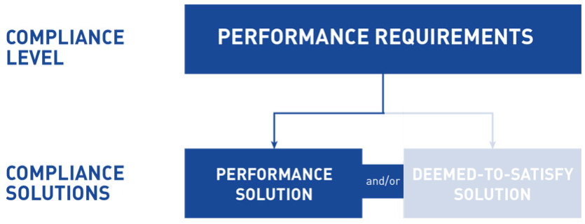

Revision # | Revision Name | Date | Author
InsertRevisionNumber | InsertRevisionName | InsertDate | InsertDesignerName

Prepared By:
InsertCompanyName
InsertCompanyAddress
InsertCompanyPhoneNumber
InsertCompanyEmail
Prepared For:
InsertClientName
InsertClientAddress
InsertClientPhoneNumber
InsertClientEmail

Executive Summary

The performance requirements that specifically relate to the sizing of water systems are BP1.2, BP2.3, and BP3.3 in the Plumbing Code of Australia (PCA) 2019.

The performance requirements BP1.2, BP2.3 and BP3.3 have been met by using a combination of a performance solution and the DTS solutions as allowed under clause A2.1(3) of PCA 2019 and have been verified in accordance clause A2.2(2)(b) and A2.4 of PCA 2019.

The sizing of a water system by following the DTS solutions of AS/NZS 3500.1:2018 Water Services and AS/NZS 3500.4:2018 Heated Water Services, results in having oversized pipes. The reason for this is because the DTS solutions are based on data collected in the mid 1900’s when fixture flow rates were a lot higher and their usage patterns were very different.

The Hydraulic Consultants Association Australasia (HCAA) have been undertaking studies on residential buildings of varying size, locations and demographics since August 20th, 2019. The results have found that the DTS solutions of AS/NZS 3500.1:2018 Water Services and AS/NZS 3500.4:2018 Heated Water Services are significantly oversized.

This Performance Solution Pertains To:

This performance solution only pertains to the water system pipe sizing where the full flow (total sum of all fixture flow rates) is equal to or above 0.2l/s and below 500l/s. This performance solution does not pertain to continuous flows such as mechanical cooling towers.

This Performance Solutions Has Been Prepared By:

Designer: InsertDesignerName
Company: InsertCompanyName
Title: InsertDesignerTitle
Qualifications: InsertDesignerQualifications
Contents

1. Introduction 4
2. Reason for the Performance Solution 4
3. Benefits of Using a Performance Solution 4
4. Assumptions & Limitations 5
5. Design Information 5
6. Overview of the Calculations Used 6
7. Overview of Compliance 7
8. Verification Against the Performance Requirements 7
9. Adopted DTS Solutions 9
10. Conclusion 13
Appendix A – Calculations 14
Appendix B – CV of Designer 15
Appendix C – Expert Assessment 16
Appendix D – HCAA Collected Data 17
Appendix E – Client Acknowledgement Letter 18
Appendix F – Network Utility Operator Acknowledgement Letter 19

Update the contents and delete this text once the template has been completed

Introduction

InsertCompanyName are engaged by InsertClientName to design the water system on InsertProjectName which is located at InsertProjectAddress. Refer to the below site plan for an overview of the project location.
InsertSitePlan

AS/NZS 3500.1:2018 Water Services and AS/NZS 3500.4:2018 Heated Water Services contain the deemed-to-satisfy (DTS) solutions on sizing water systems to ensure compliance with the performance requirements of the National Construction Code (NCC) 2019. The performance requirements that specifically relate to the sizing of water systems are BP1.2, BP2.3, and BP3.3 in the Plumbing Code of Australia (PCA) 2019.
However, AS/NZS 3500.1:2018 Water Services and AS/NZS 3500.4:2018 Heated Water Services are not fit for purpose when designing residential buildings due to their outdated and conservative probable simultaneous demand (PSD) conversion method.

Reason for the Performance Solution

The sizing of a water system by following the DTS solutions of AS/NZS 3500.1:2018 Water Services and AS/NZS 3500.4:2018 Heated Water Services, results in having oversized pipes. The reason for this is because the DTS solutions are based on data collected in the mid 1900’s when fixture flow rates were a lot higher and their usage patterns were very different.
The Hydraulic Consultants Association Australasia (HCAA) have been undertaking studies on residential buildings of varying size, locations and demographics since August 20th, 2019. The results have found that the DTS solutions of AS/NZS 3500.1:2018 Water Services and AS/NZS 3500.4:2018 Heated Water Services are significantly oversized.

Benefits of Using a Performance Solution

In summary, the benefit of using a performance solution for the water system pipe sizing is that you generally get smaller diameter pipes. As a result of this, the clients received a design that:
- Requires less energy from the heated water circulating pump to overcome heat loss
- Has reduced spatial requirements for the riser, takes up less ceiling space, and the pumps and the like have a smaller footprint
- Has a reduced capital cost
- Has a lower carbon footprint due to the embodied energy saved in materials
- Reduces the stagnation of water within the pipes
- AddOtherBenefitsIfThereAreAny:

Assumptions & Limitations

The following items have been assumed within our design:

- AddAssumptionsOrStateThereAreNone

The following items have been limitations so far within our design:

- AddLimitationsOrStateThereAreNone

Design Information

This performance solution pertains only to the water systems in the buildings shown in the below.

InsertDrawing(s)ShowingBuildingThatThisPerformanceSolutionPertainsTo

The flow rates of the fixtures within the building is shown below:

Fixture | Cold Flow Rate (L/sec) | Heated Flow Rate (L/sec) | Non-Drinking Flow Rate (L/sec)
Basin | 0.1 | 0.1 | N/A
WC | 0.1 | N/A | ?
Shower | 0.1 | 0.1 | N/A
Sink | 0.1 | 0.2 | N/A
Washing Machine | 0.2 | 0.2 | ?
Dishwashing Machine | 0.2 | 0.2 | N/A
Bath | 0.3 | 0.3 | N/A

Confirm the above flow rates are correct. Add and delete as necessary.

Overview of the Calculations Used

An overview of the calculation that needs to be undertaken when following DIN1988-300:2012-05 is shown below.

((NAW).)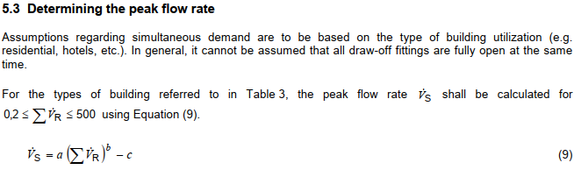
((NAW).)
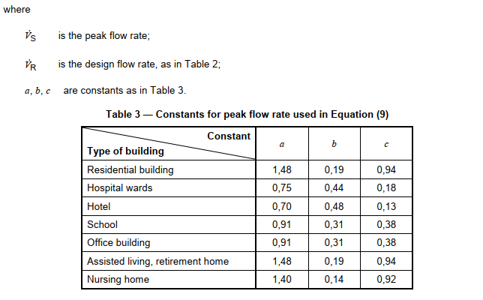

Overview of Compliance

The below table identifies the different levels of governance that needs to be complied with when undertaking and certifying a water system sizing design:
Generic Regulatory Requirement | Specific Regulatory Requirement
State & Territory Building Act | Plumbing & Drainage Act (NSW) 2011
State & Territory Building Regulation | Plumbing & Drainage Regulation (NSW) 2017
Technical Standard | PCA 2019 (Volume Three)

To comply with the PCA 2019, we have followed the following process:
PCA Compliance Options | Specific PCA Compliance
Performance Solution and/or DTS | A combination of Performance Solution and DTS - A2.1(3)
Meeting the Performance Requirements | Other Verification Method - A2.2(2)(b)
Verification Method | A calculation, using analytical methods or mathematical models and a test, using a technical procedure, either on-site or in a laboratory to directly measure the extent to which the performance requirements have been met – A2.4 Explanatory Information

Verification Against the Performance Requirements

The below table identifies the performance requirements that need to be complied with when designing a water system. Also noted in the table is how verification has been achieved:
Clause | Requirement | Verification
BP1.2  Design, construction and installation | 1) A cold water service must ensure the following:  a. Water is provided at required flow rates and pressures for the correct functioning of fixtures and appliances  b. Access for maintenance of mechanical components and operational controls.  c. The system, appliances and devices can be isolated for testing and maintenance.  d. The efficient use of drinking water.  2) A cold water service must avoid failure or uncontrolled discharge. | The performance solution only relates to BP1.2 (1)(a) and verification has been achieved based on both:  1 - sizing the water system with the use of a recognised engineering formula (DIN1988-300:2012-05) and  2 - in line with the results from the live data that the HCAA has collected  This is in line with what is accepted within the PCA’s verification methods for undertaking a performance solution.  The DTS solutions will be followed for all of the other requirements.
BP2.3  Design, construction and installation | 1) A heated water service must ensure the following:  a. Heated water is provided at required flow rates and temperatures for fixtures and appliances to function  b. Access for maintenance of mechanical components and operational controls.  c. The system, appliances and devices can be isolated for testing and maintenance.  2) A heated water service must be designed, constructed and installed to avoid failure or uncontrolled discharge. | The performance solution only relates to BP2.3 (1)(a) and verification has been achieved based on both:  1 - sizing the water system with the use of a recognised engineering formula (DIN1988-300:2012-05) and  2 - in line with the results from the live data that the HCAA has collected  This is in line with what is accepted within the PCA’s verification methods for undertaking a performance solution.  The DTS solutions will be followed for all of the other requirements.
BP3.3  Design, construction and installation | 1) A non-drinking water service must ensure the following:  a. Non-drinking water is provided at required flow rates and pressures for the correct functioning of fixtures and appliances  b. Access for maintenance of mechanical components and operational controls.  c. The system, appliances and devices can be isolated for testing and maintenance.  2) A non-drinking water service must be designed, constructed and installed to avoid failure or uncontrolled discharge. | The performance solution only relates to BP3.3 (1)(a) and verification has been achieved based on both:  1 - sizing the water system with the use of a recognised engineering formula (DIN1988-300:2012-05) and  2 - in line with the results from the live data that the HCAA has collected  This is in line with what is accepted within the PCA’s verification methods for undertaking a performance solution.  The DTS solutions will be followed for all of the other requirements.

Adopted DTS Solutions

The performance solution also uses some DTS solutions from AS/NZS 3500.1:2018 Water Services to achieve compliance with the performance requirements as noted in the above sections. The adopted DTS solutions are noted in the table below:

Section | Clauses Adopted | Notes
Section 1  Scope and General | All | Followed but the section is not wholly applicable to water system pipe sizing
Section 2  Materials and Products | None | Not applicable to water system pipe sizing
Section 3  Sizing of Water Services | 3.3, 3.4 | The pressure and the velocity requirements have been adopted to assist in the water system pipe sizing
Section 4  Cross Connection Control and Backflow Prevention | None | Not applicable to water system pipe sizing
Section 5  Installation of Cold Water Services | None | Not applicable to water system pipe sizing
Section 6  Fire Services | None | Not applicable to water system pipe sizing
Section 7  Irrigation and Lawn Watering Systems | None | Not applicable to water system pipe sizing
Section 8  Water Storage Tanks | None | Not applicable to water system pipe sizing
Section 9  Non-Drinking Water Services | None | Not applicable to water system pipe sizing
Section 10  Treated Greywater Services | None | Not applicable to water system pipe sizing
Section 11  Water for Sanitary Flushing | None | The pipe sizing for the flushing water will be determined based on the flow rate and maximum velocity
Section 12  Installation of Water Supply to Specified Fixtures | None | Not applicable to water system pipe sizing
Section 13  Pumps | None | Not applicable to water system pipe sizing
Section 14  Water Requirements for Haemodialysis Machines | ? | Are there Haemodialysis Machines in the project, did you comply with this?
Section 15  Property Water Meters | None | Not applicable to water system pipe sizing
Section 16  Installation of Water Supply Systems from Rainwater Tanks | None | Not applicable to water system pipe sizing
Section 17  Multi-Unit Developments | None | Not applicable to water system pipe sizing
Section 18  Testing and Commissioning | None | Not applicable to water system pipe sizing
Appendix A  Equivalent Pipe Sizes | All | The pipes have been sized based on these tables
Appendix B  Acceptable Pipes and Fittings | None | Not applicable to water system pipe sizing
Appendix C  Sizing Method for Supply Piping for Dwellings | Informative | This section does not form part of the DTS solutions
Appendix D  Sizing of Piping for Dwellings | Informative | This section does not form part of the DTS solutions
Appendix E  Examples of Potential Cross-Connections | Informative | This section does not form part of the DTS solutions
Appendix F  Types of Backflow Prevention | Informative | This section does not form part of the DTS solutions
Appendix G  Storage Tanks – Inflow and Overflow | Informative | This section does not form part of the DTS solutions
Appendix H  Cleaning and Disinfections of Storage Tanks | None | Not applicable to water system pipe sizing
Appendix I  Disinfection of Water Services | None | Not applicable to water system pipe sizing

The performance solution also uses some DTS solutions from AS/NZS 3500.4:2018 Heated Water Services to achieve compliance with the performance requirements as noted in the above sections. The adopted DTS solutions are noted in the table below:
Section | Clauses Adopted | Notes
Section 1  Scope and General | All | Followed but the section is not wholly applicable to water system pipe sizing
Section 2  Materials and Products | None | Not applicable to water system pipe sizing
Section 3  Cross Connection and Backflow Prevention and Thermostatic Mixing Valves | None | Not applicable to water system pipe sizing
Section 4  Installation of Cold and Heated Water Piping and Controls | None | Not applicable to water system pipe sizing
Section 5  Installation of Water Heaters – General Requirements | None | Not applicable to water system pipe sizing
Section 6  Installation of Solar Water Heaters | None | Not applicable to water system pipe sizing
Section 7  Uncontrolled Heat Sources | None | Not applicable to water system pipe sizing
Section 8  Energy Efficiency | None | Not applicable to water system pipe sizing
Section 9  Testing and Commissioning | None | Not applicable to water system pipe sizing
Section 10  Sizing and Installation of Circulatory Heated Water Reticulation | None | Not applicable to water system pipe sizing
Appendix A  Water Analysis | Informative | This section does not form part of the DTS solutions
Appendix B  Acceptable Pipes and Fittings | None | Not applicable to water system pipe sizing
Appendix C  Internal Pipe Diameters | All | The pipes have been sized based on these tables
Appendix D  Preferred Sizes of Pipes for Non-Circulatory Typical Single Store Household Installations | Informative | This section does not form part of the DTS solutions
Appendix E  Recommendations for the Installation of Unrated Solar Heated Water Supply Systems | Informative | This section does not form part of the DTS solutions
Appendix F  Recommendations for the Installation of Close Coupled and Integral Solar Heated Water Supply Systems on Roofs | Informative | This section does not form part of the DTS solutions
Appendix G  Solar Heated Water Supply Systems – Suggested Component Sizes (Custom Built Systems) | Informative | This section does not form part of the DTS solutions
Appendix H  Estimation of Shading of Collectors | Informative | This section does not form part of the DTS solutions
Appendix I  Effect of Inclination and Orientation on System Performance | Informative | This section does not form part of the DTS solutions
Appendix J  Map of Regional Basic Design Wind Speeds | Informative | This section does not form part of the DTS solutions
Appendix K  Australian Climate Regions | None | Not applicable to water system pipe sizing
Appendix L  New Zealand Climate Regions | None | Not applicable to water system pipe sizing
Appendix M  Operation and Maintenance | Informative | This section does not form part of the DTS solutions
Appendix N  Provision for Expansion and Contraction | None | Not applicable to water system pipe sizing
Appendix O  Estimation of Probable Simultaneous Demand for Residential Buildings from the Total of Loading Units | Informative | This section does not form part of the DTS solutions
Appendix P  Sizing of Expansion Vessels in Mains Pressure Systems | None | Not applicable to water system pipe sizing

Note that there are other sections of AS/NZS 3500.1:2018 Water Services and AS/NZS 3500.4:2018 Heated Water Services that have been followed in the project that do not form part of this performance solution. Confirm these clauses are correct for your project and edit as necessary

Conclusion

To conclude, the performance requirements BP1.2, BP2.3 and BP3.3 have been met by using a combination of a performance solution and the DTS solutions as allowed under clause A2.1(3) of PCA 2019 and have been verified in accordance clause A2.2(2)(b) and A2.4 of PCA 2019.

Refer to the appendices for more information on the calculations/ results, acknowledgement of the performance solution from the client and further information on the designer and expert reviewer.

Appendix A – Calculations

InsertAllRelevantCalculationsIncludingTheResults

Appendix B – CV of Designer

InsertYourCV

Appendix C – Expert Assessment

InsertReviewerCompanyName have reviewed this performance solution and agree that the right process has been followed and the performance requirements have been met.

Reviewer: InsertReviewerName
Company: InsertReviewerCompanyName
Title: InsertReviewerTitle
Qualifications: InsertReviewerQualifications
Signature: InsertSignature

Appendix D – HCAA Collected Data

InsertSummaryOfCollectedData

The results can also be viewed on the live website www.waterdemand.com.au

Appendix E – Client Acknowledgement Letter

Dear InsertClientName,

InsertProjectName

InsertProjectAddress

Performance Solution – Water System Pipe Sizing

By signing the below, you confirm that you have reviewed this performance solution, understand the reason why a performance solution is required and have no objections to the use of a performance solution.

Name: ClientToAddThis

Title: ClientToAddThis

Signature: ClientToAddThis

Appendix F – Network Utility Operator Acknowledgement Letter

Dear InsertNetworkUtilityOperatorName,

InsertProjectName

InsertProjectAddress

Performance Solution – Water System Pipe Sizing

By signing the below, you confirm that you have reviewed this performance solution, understand the reason why a performance solution is required and have no objections to the use of a performance solution.

Name: NetworkUtilityOperatorToAddThis

Title: NetworkUtilityOperatorToAddThis

Signature: NetworkUtilityOperatorToAddThis

